

**Computer systems Report**

**smart irrigation systems**

Mohamed Temer Shebita 211000379

Jaser Osama Kasim 211001801

Ahmed Salah Kamal 211001546

Ziad Ehab Alfahham 212002283

Osama Tharwat 211000589

Ecen305

December 2023

**1.smart irrigation systems**

The advent of the Internet of Things (IoT) has revolutionized the realm of agriculture, offering innovative solutions to enhance efficiency and sustainability. One such application is the IoT-based control and automation of smart irrigation systems. In traditional agricultural practices, water management has been a critical factor, often relying on manual methods that may lead to overuse or insufficient water supply. The integration of IoT technology into irrigation systems brings about a paradigm shift by enabling real-time monitoring, data-driven decision-making, and automated control. This transformative approach empowers farmers to remotely manage and optimize their irrigation processes, utilizing sensor data to assess soil moisture levels and weather conditions. As a result, the IoT-based smart irrigation system not only conserves water resources but also enhances crop yield and promotes sustainable agricultural practices. This introduction reflects the intersection of cutting-edge technology and agriculture, showcasing how IoT is reshaping traditional methods to create more intelligent and efficient farming systems.

**2.The mechanism of irrigation systems**

The artificial application of water to the soil or land to promote the growth of crops and vegetation is referred to as an irrigation system. These systems are made to enhance rainfall that occurs naturally and guarantee that plants get enough water to grow to their full potential. Different irrigation system types have different ways of distributing water. Typical varieties include some of the following:

* **Drip irrigation:**

Uses a system of emitter-equipped tubes or hoses to supply water straight to each plant's base. This technique is very effective at saving water because it reduces runoff and evaporation.

* **sprinkler irrigation:**

Water is sprayed or distributed in droplets over the crops using a sprinkler irrigation system. Sprinklers work well with a variety of crops and can be either stationary or mobile.

* Surface irrigation is the process of applying water to the soil's surface through controlled flooding or gravity flow. This technique involves irrigation in borders, basins, and furrows.
* Water is delivered below the soil's surface via subsurface irrigation, which uses tubes or buried pipes. This technique, which is frequently applied in drip and soaker hose systems, lowers water loss from evaporation.

**3.Advantages of Watering Systems:**

* Enhanced Crop Yields: Irrigation guarantees that crops receive the right amount of water for healthy growth and development by supplying a steady and regulated water supply. Crop quality is enhanced, and yields are raised as a result.
* Water Conservation: Drip irrigation is one method used by irrigation systems to reduce water waste. These systems are made to use water resources as efficiently as possible. This is particularly important in areas where water is scarce.
* Better Timing of Water Supply: Farmers can plan and manage when to apply water, so crops get water when they need it most. This is made possible by irrigation. This is especially crucial in dry spells and in regions with erratic rainfall.
* Crop diversification: Farmers can plant a range of species and diversify their crops with dependable water sources, resulting in more resilient and sustainable farming methods.
* Decreased Dependency on Rainfall: Throughout the year, irrigation offers agriculture a consistent and dependable supply of water by reducing reliance on erratic and seasonal rainfall.
* Reduced Effects of Drought: Irrigation systems can lessen the effects of drought on crops, avoiding crop losses and sustaining food production.
* Enhanced Land Productivity: By increasing the amount of arable land and raising the overall land productivity, irrigation makes it possible to cultivate in regions that would not otherwise be suitable for agriculture owing to insufficient rainfall.

**4.Some commonly used components:**

**4.1.Passive Infrared Sensor, or PIR Sensor:**

PIR sensors are sensitive to variations in the amount of infrared radiation that strikes them; these variations are contingent upon the surface characteristics and temperature of the objects in front of the sensor. The temperature at that location in the sensor's field of view will increase from room temperature to body temperature and back again when an object, like a person, moves in front of the background, like a wall. The detection is initiated by the sensor changing the output voltage in response to the resulting change in the incoming infrared radiation. Similar-temperature objects with different surface properties might also emit infrared light differently, so shifting them in relation to the background could also set off the detector.

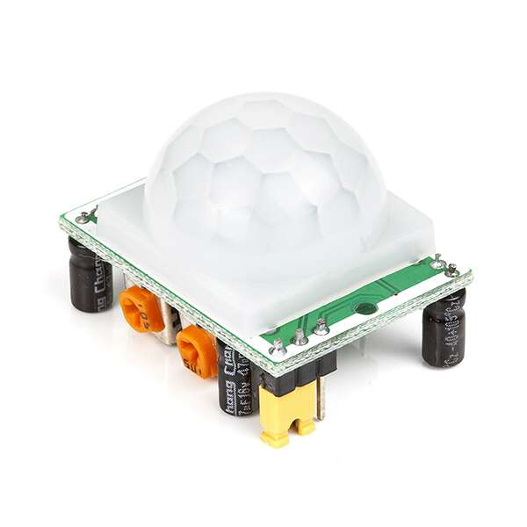

**4.2.DHT11 Sensor:**

The DHT11 sensor is a compact and affordable device designed primarily for measuring temperature and humidity in various applications. Featuring a resistive humidity element and a thermistor for temperature sensing, the DHT11 employs a microcontroller to convert analog signals into digital output. With a temperature range typically spanning 0°C to 50°C (32°F to 122°F) and a humidity range between 20% to 90% relative humidity, the sensor provides moderate accuracy suitable for basic and hobbyist projects. Its digital output facilitates easy interfacing with popular microcontrollers like Arduino or ESP8266.

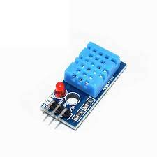

**4.3.Light Dependent Resistor, or LDR, Sensor:**

The Light Dependent Resistor (LDR) sensor, also known as a photoresistor, is a photosensitive device widely used for detecting and measuring light levels in various applications. Its resistance changes in response to incident light intensity, making it a valuable component for light-sensitive circuits. The LDR consists of a semiconductor material that exhibits decreased resistance in well-lit conditions and increased resistance in darkness. Commonly employed in ambient light sensing, it finds applications in automatic lighting systems, camera exposure control, and other light-dependent automation tasks. With a simple structure, the LDR is often integrated with microcontrollers like Arduino or Raspberry Pi for light-dependent control.

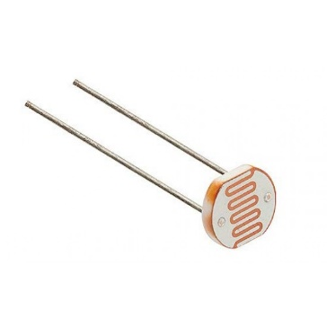

**4.4.soil moisture sensor:**

A soil moisture sensor is a vital component in agricultural and watering systems, specifically designed to measure the moisture content of the soil. These sensors come in various types, including capacitive sensors that gauge the soil's dielectric constant, resistance or densiometric sensors that measure electrical resistance influenced by moisture levels, and volumetric sensors assessing the water volume in the soil. Integrated with microcontrollers such as Arduino or Raspberry Pi, soil moisture sensors enable real-time monitoring and automation of irrigation systems. This technology contributes to water conservation by optimizing irrigation, preventing overwatering, or underwatering, and promoting healthier crop growth. The data provided by soil moisture sensors aids farmers in making informed decisions about irrigation schedules and ensures efficient water usage in farming practices. Overall, these sensors play a crucial role in modern agriculture, offering a proactive approach to soil moisture management for enhanced crop health and water resource conservation.

It is necessary to calibrate the relationship between the measured property and soil moisture, which may change based on environmental elements like soil type, temperature, or electric conductivity. In hydrology and agriculture, reflected microwave radiation is used for remote sensing and is influenced by soil moisture. Farmers and gardeners can both use portable probe instruments.

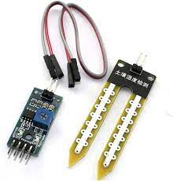

**Photos of the project**

